**NAME- ANANYA KALIA**

**500122859**

**BATCH-11**

**R2142230337**

# AIML ASSIGNMENT-2

Develop a Flask-based UI to use the ML/DL model developed in the Assignment – 1. Upload your all the resources on GitHub.

## Overview

This Flask application is a web-based platform designed to predict whether a person is diabetic based on input data. It uses a pre-trained machine learning model for predictions, which is loaded and invoked in the backend via a function called preprocess_and_predict.

## Key Features

1. **Interactive Web Form**: o The app displays a webpage where users can enter health-related details like glucose levels, BMI, and age.
2. **Machine Learning Prediction**: o The app uses a machine learning model to analyze the provided data and predict whether the person is diabetic.
3. **Results Display**: o After prediction, the result ("Diabetic" or "Non-Diabetic") is shown on the same webpage.

## How It Works

1. **User Interaction**:

o The user visits the webpage and fills out a form with their health information, such as blood pressure, insulin levels, and glucose readings.

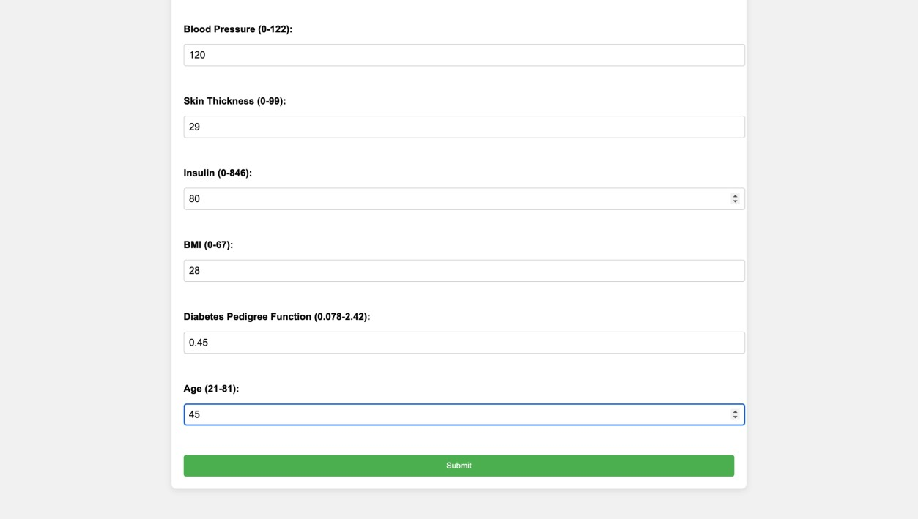

1. **Data Submission**: o Once the form is submitted, the data is sent to the app for processing.

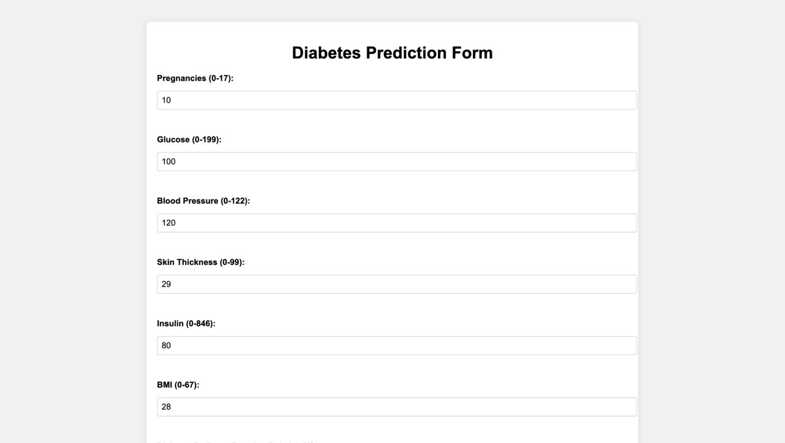

1. **Processing and Prediction**:
   * The app preprocesses the input data and uses a pre-trained model to make a prediction.
2. **Result Display**:
   * The app sends the prediction back to the webpage, displaying whether the user is "Diabetic" or "Non-Diabetic."

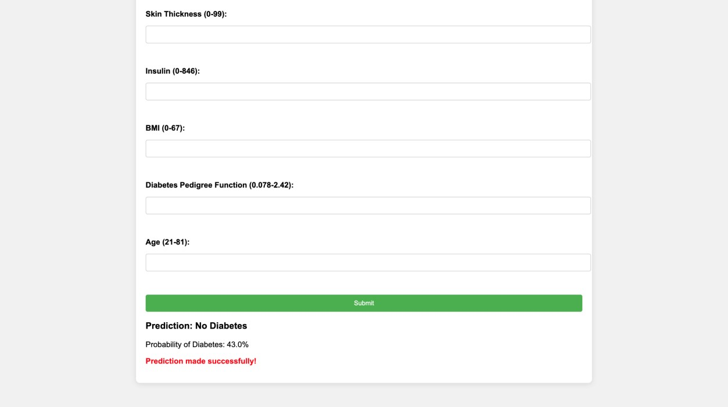

## Components of the App

1. **Backend (Flask App)**:
   * Handles user requests and predictions.
   * Processes the input data and communicates with the machine learning model.
2. **Prediction Model**:
   * A pre-trained machine learning model is used to make predictions based on the user’s input.
3. **Frontend (Webpage)**: o A simple HTML form collects data from the user. o The prediction result is displayed dynamically on the same page after submission.